Natchez Trace State Park
Lexington, TN
May 16-19, 2019

The West Tennessee Travelers held their May campout at Natchez Trace State Park, Lexington, TN. Some arrived early to enjoy the quiet solitude before the park filled up for the weekend. By Thursday evening, nineteen WTT members were enjoying the relatively cool evening.
We welcomed Raoul and Arlene Sanchez and Melissa Stephens to their first campout as WTT members.
Friday we held our club meeting and elected officers for our 2019-2020 camping season: Jeannette Dixon as President, Diana Logan as Vice President, Ken Dixon as Secretary and Cliff Klein as Treasurer. Past President Larry Bolding administered the oath of office to all. Our thanks go out to those who stepped forward to take the reins of leadership
Since Mark’s campsite had the most area and shade, we gathered there for our pot luck dinner featuring a delicious ham. Thanks to the Kleins for the entree and to all the other folks for the fixin’s that went with it. After stuffing ourselves on an excellent meal, we spent the evening getting to know everyone again and telling tall tales around the campfire.

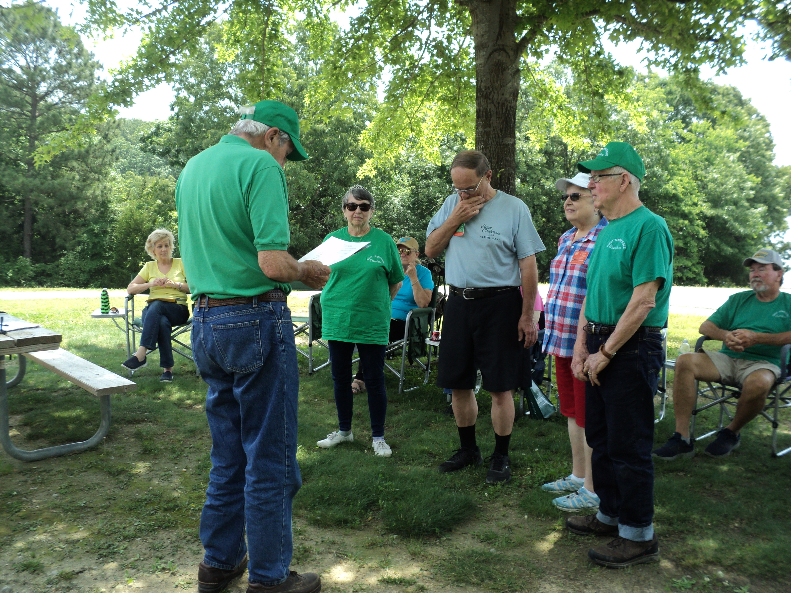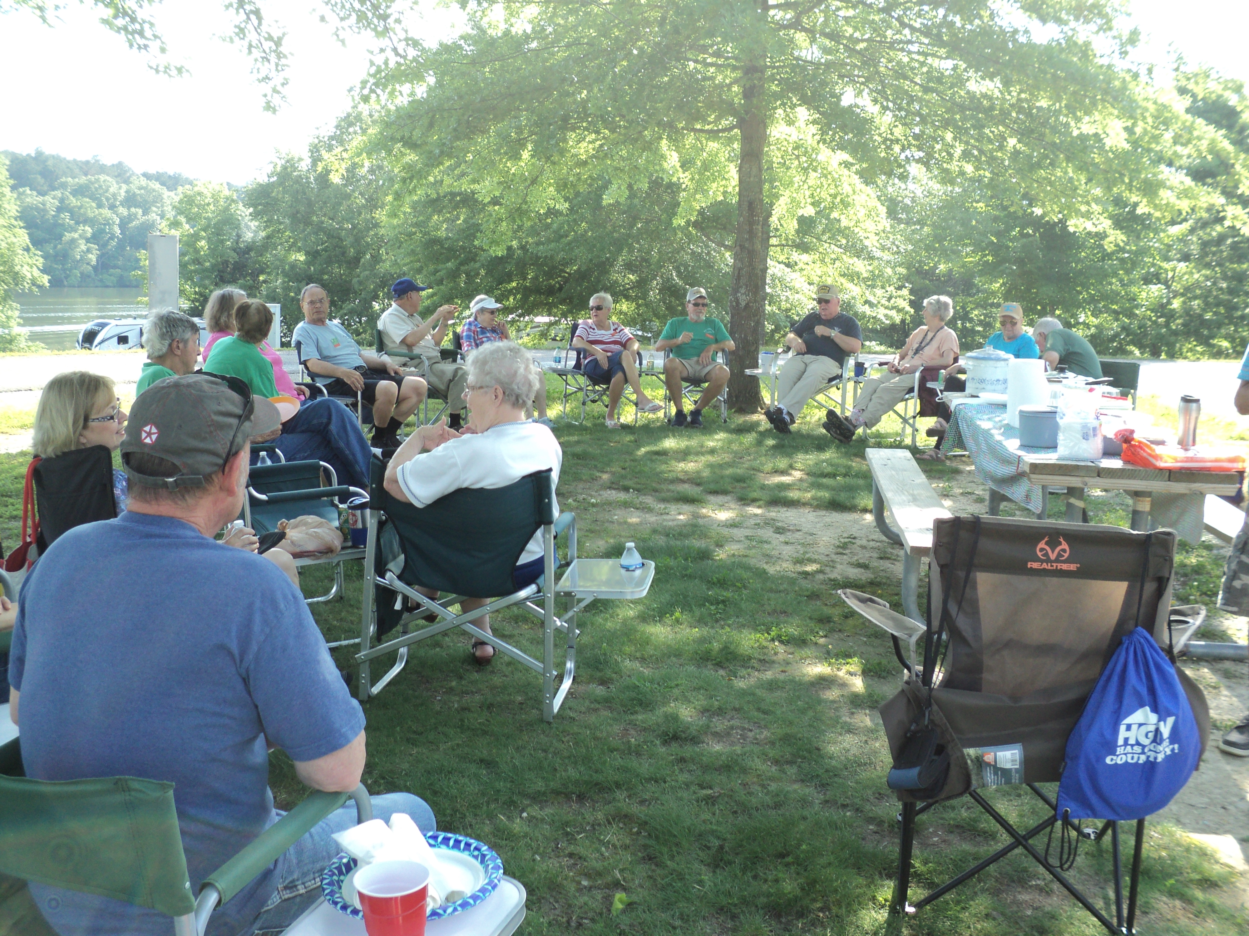

Saturday dawned clear and warm so we showed little interest in games of competition such as corn hole, ladder golf and various card games. Instead we found cool shades to continue to get reacquainted and welcome our newest members to our laid back style of camping. I hope everyone enjoyed the relaxation as much as I did. When the dining hour arrived, we carpooled to the Pin Oak Lodge for a delicious barbeque buffet with peach cobbler and soft serve ice cream for dessert.

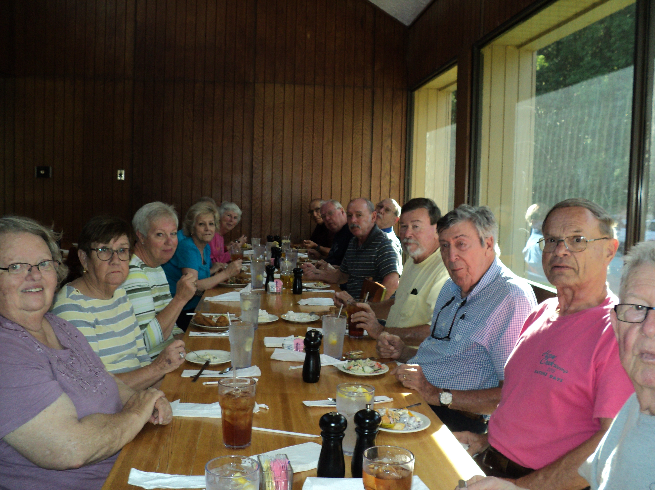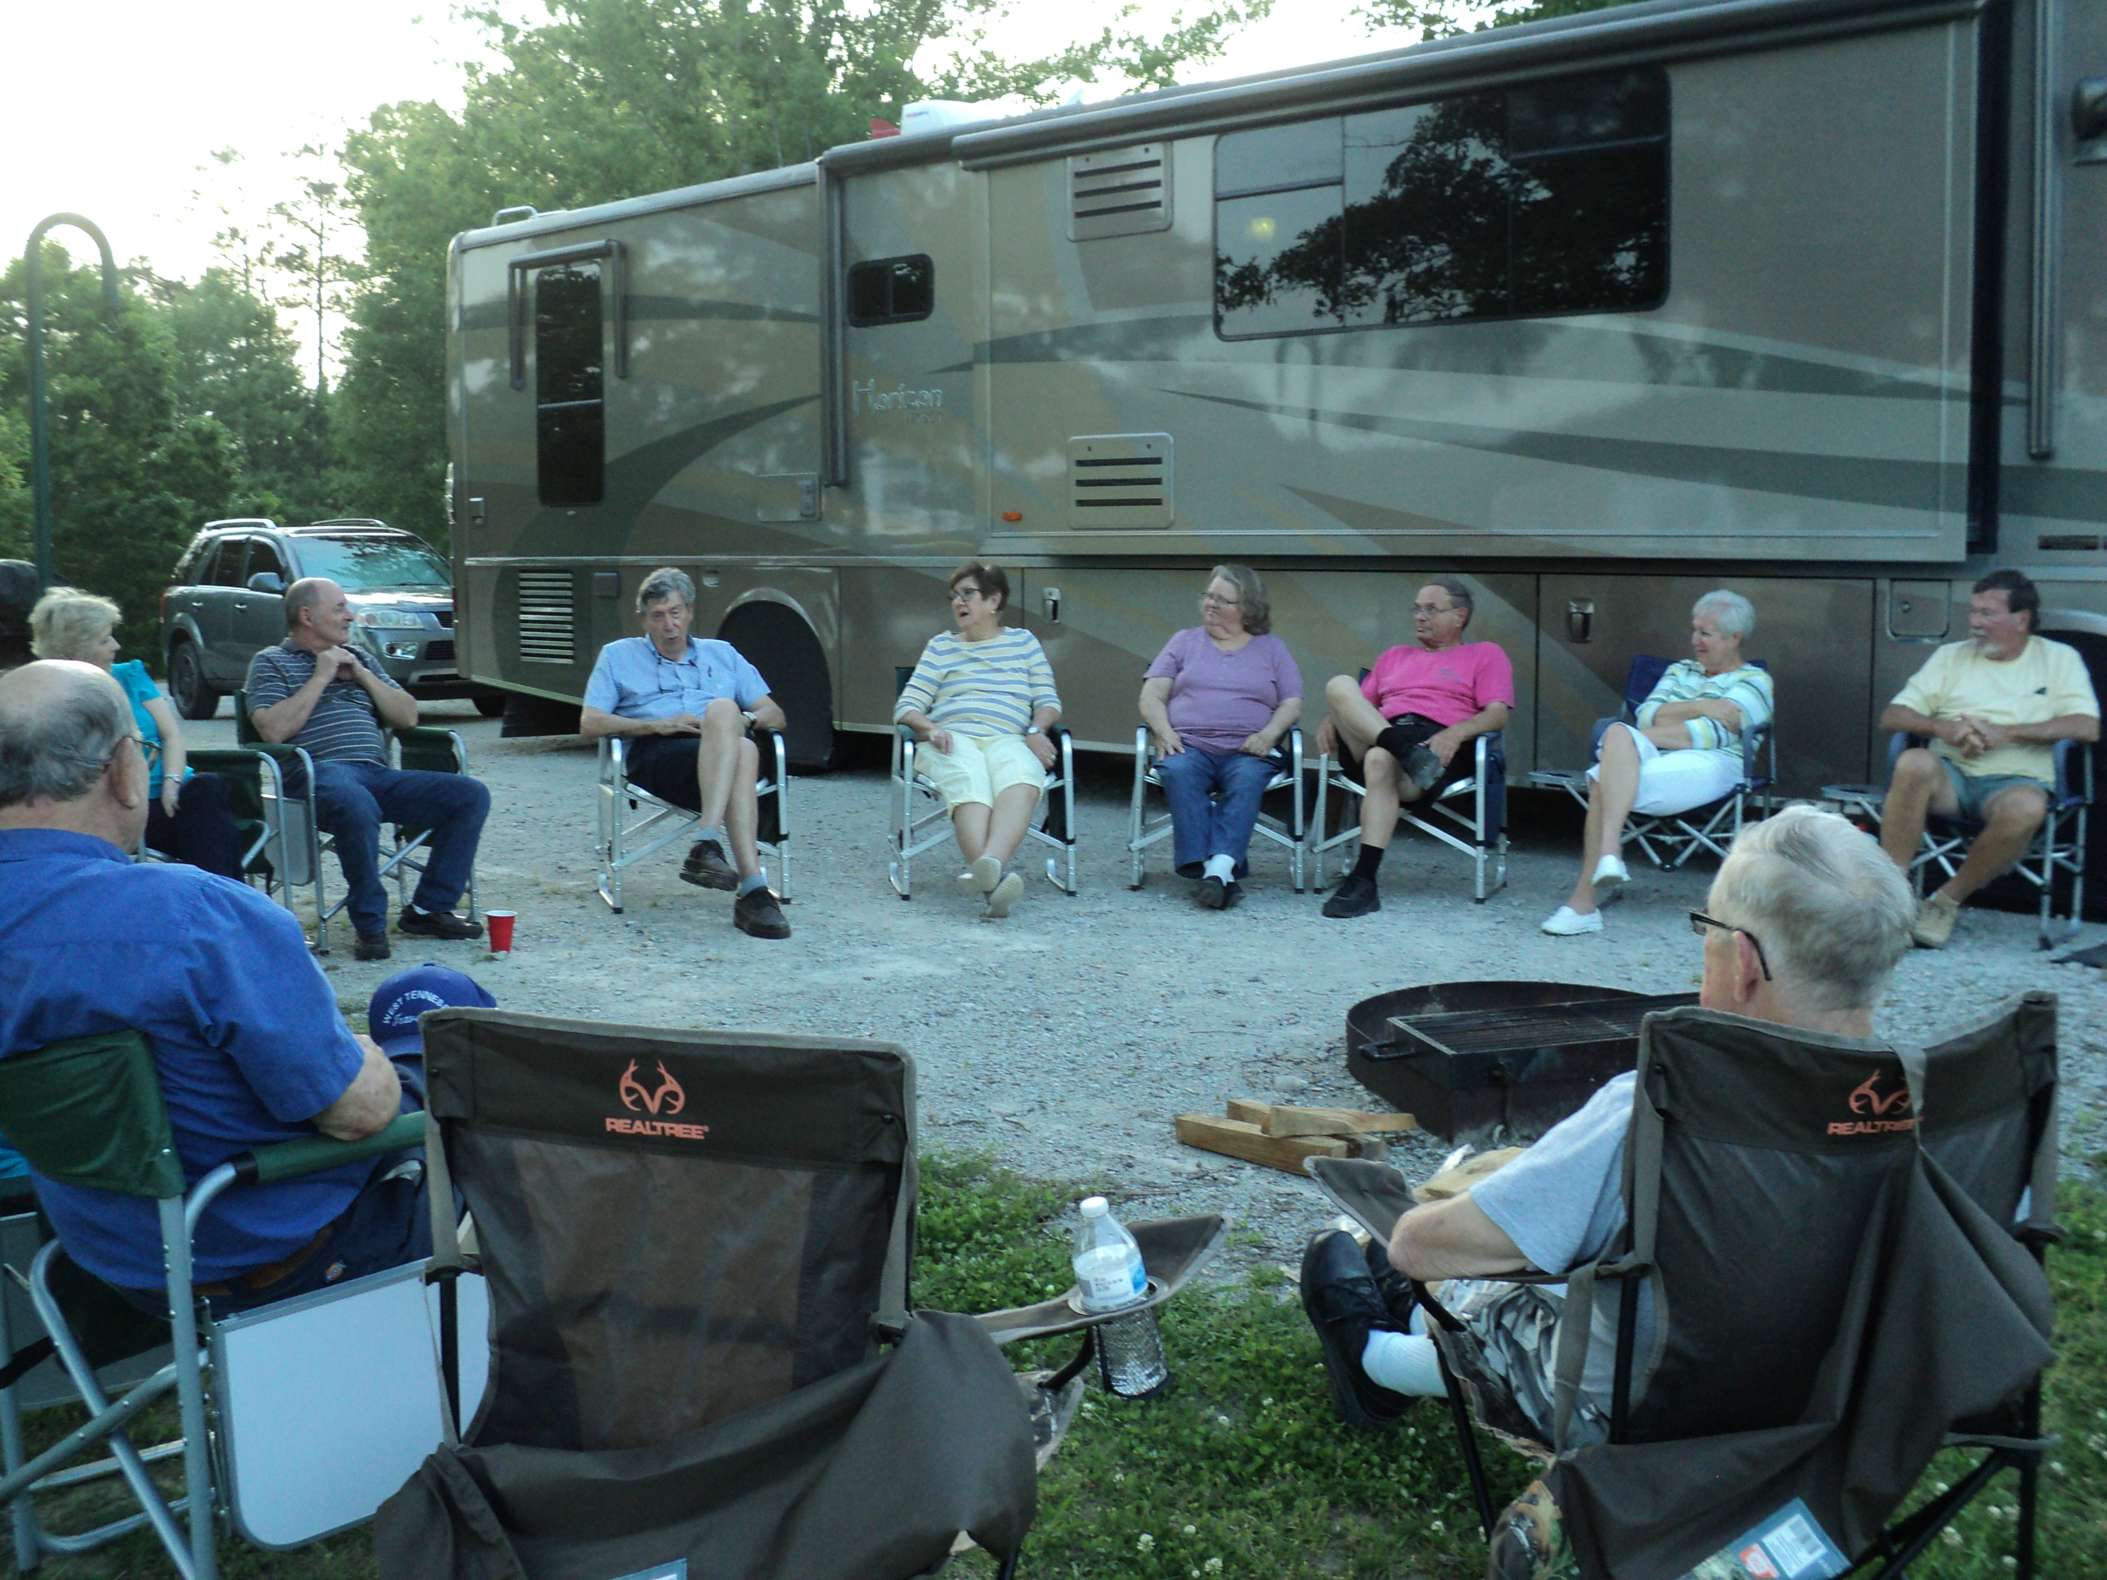

After dinner, we reverted to our favorite pastime gathered around Mark’s campsite and continued our tall tales. For those who missed it, be sure to ask Larry about his story of a burial-at-sea. It definitely bears retelling.
Since the weather forecast called for showers Sunday, most everyone packed up early in preparation for our departure. Hope to see all at Columbus-Belmont next month.
We also want to express our appreciation to Cliff & Kay for a fine hosting.

Ken Dixon, Sec

